Nama : Jefri Haris Laksmana  
NIM : 18090025  
Kelas : 5D

Laporan Praktikum 2

1. Source Code

model1.php -> application/models/

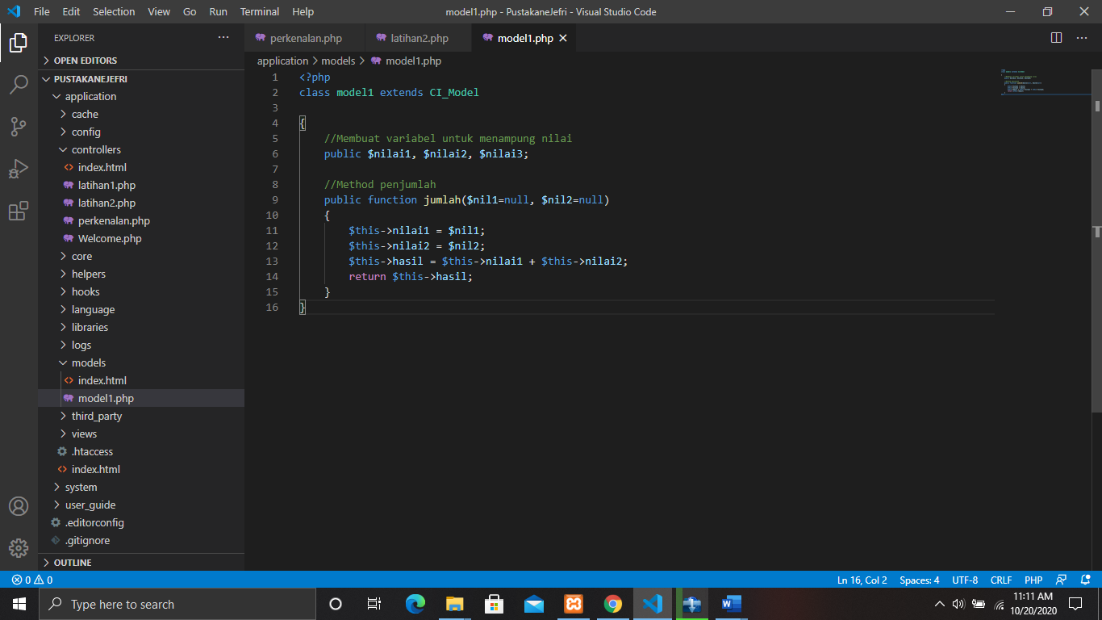

Latihan1.php -> application/controllers/

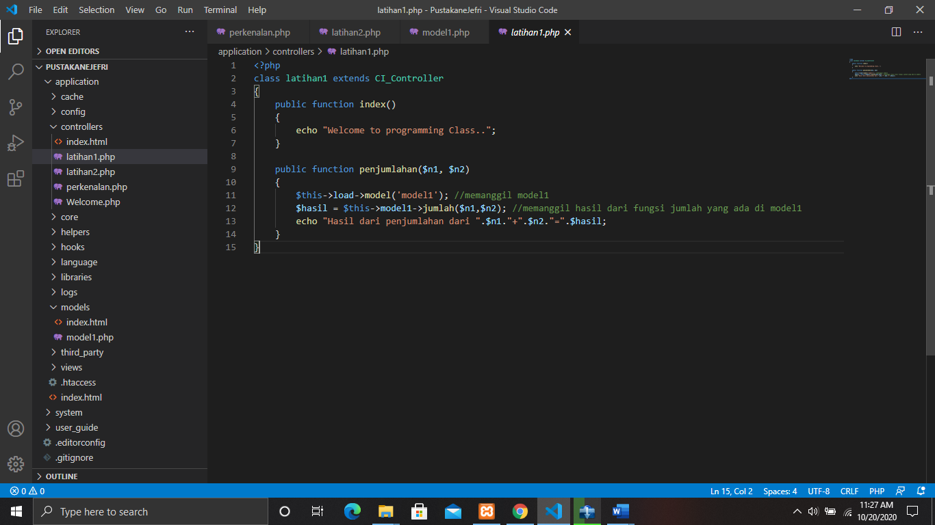

Latihan2.php -> application/controllers/  
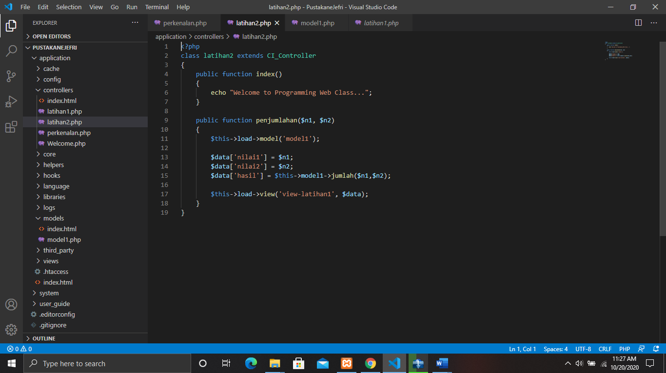

View-latihan1.php -> application/views/  
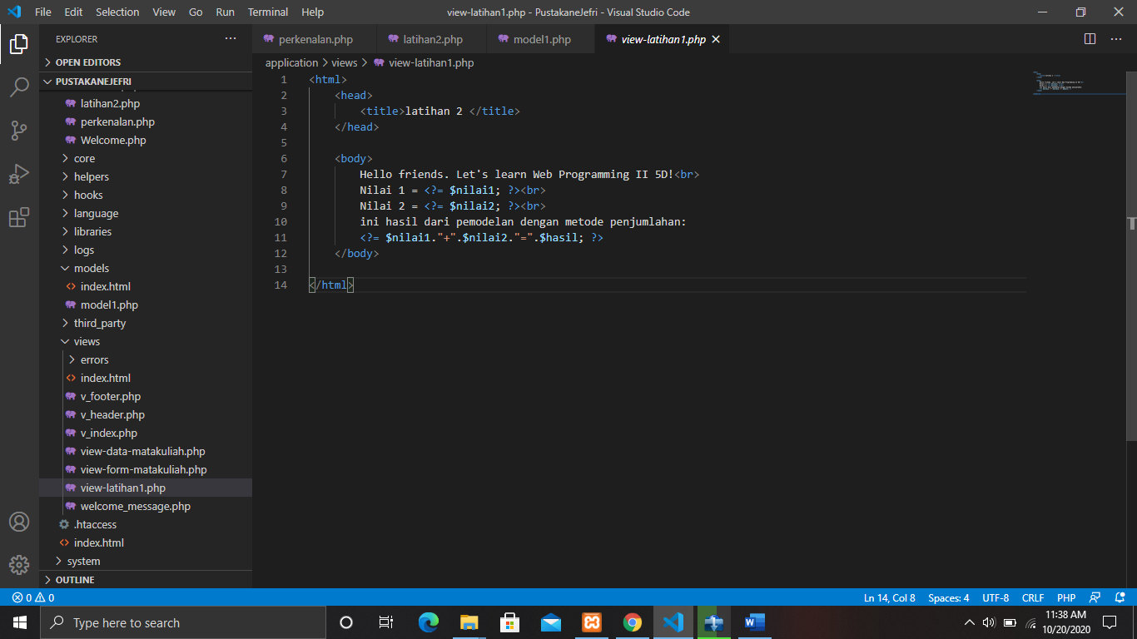

1. URL

<http://localhost/PustakaneJefri/index.php/latihan1>

<http://localhost/PustakaneJefri/index.php/latihan2/penjumlahan/5/6>

1. Capture Output Program

